Employee Details Form

Name:
Aryan Sharma  Father Name: Arun Kumar Sharma | 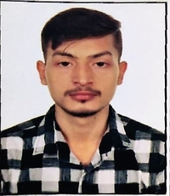

Designation: Software Test Engineer- Trainee

Gender: [M / F]  MALE | Age:  22 YEARS | Date of Birth:  23 NOV 1999 | Marital Status:  SINGLE
Blood Group: A+

Pan Card No: ILBPS7417F

E-mail Address:
arsh8254@gmail.com

Permanent Address:
House No. 34 Near Shiv Mandir Lakhipur Patna Bihar- 803202

Contact Address :

House No. 34 Near Shiv Mandir Lakhipur Patna Bihar- 803202

Name & contact number in case of emergency:
Arun Kumar Sharma
8539895145

Telephone Number:  Res: Office: |  | Mobile:  8847474257

Date: 23 JAN 2022

Place: LAKHIPUR
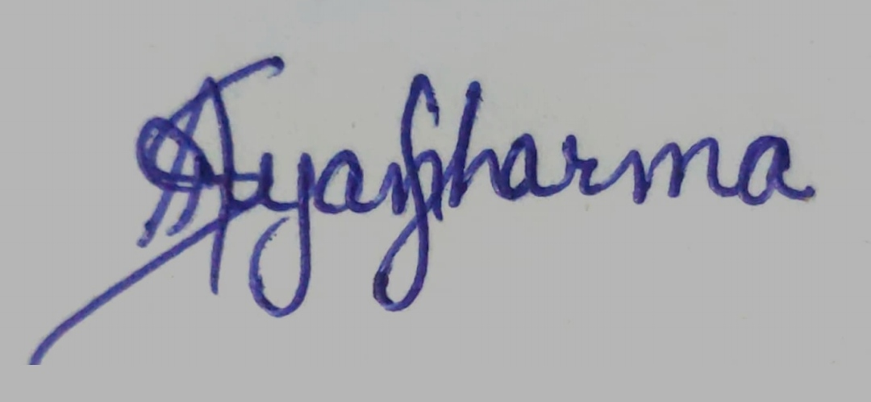

Signature:

